📝 Mini Project: Bank Account System using Abstraction in Java

Name : Nikilesh Prakash V

Reg No :411625149029

Department :Cyber Security

Subject :OOP(Object-Oriented Programming )

Batch : 4

Aim
To design and implement a Bank Account System using abstraction in Java. The program demonstrates OOP concepts such as abstract classes, encapsulation, polymorphism, and constructors. It allows users to create accounts, deposit money, withdraw money, and view account details interactively.

Procedure

Step 1: Creating the Abstract Class
- Defined an abstract class BankAccount with private data members: account number, holder name, balance, and account type.
- Declared abstract methods deposit() and withdraw().
- Provided concrete methods for displaying account details and updating balance.

Step 2: Implementing Subclasses
- SavingsAccount: Normal account with no overdraft facility.
- CurrentAccount: Allows overdraft up to a fixed limit.

Step 3: Designing the Menu System
- Used Scanner for user input.
- Displayed a menu with options: Deposit, Withdraw, Display Account, Exit.
- Loop continues until user chooses Exit.

Step 4: Applying OOP Concepts
- Encapsulation: Private data members accessed via methods.
- Abstraction: Abstract class hides implementation details.
- Polymorphism: Abstract reference pointing to different account types.
- Reusability: Separate classes for different account types.

Step 5: Execution and Testing
- Tested with Savings and Current accounts.
- Verified deposit, withdrawal, overdraft, and invalid inputs.
- Displayed transaction receipts after each operation.

Code
import java.io.*; import java.util.*; abstract class BankAccount { private String accountNumber; private String accountHolderName; private double balance; private String accountType; public BankAccount(String accountNumber,String accountHolderName,double balance,String accountType) { this.accountNumber=accountNumber; this.accountHolderName=accountHolderName; this.balance=balance; this.accountType=accountType;
}
public abstract void deposit(double amount); public abstract void withdraw(double amount); public double getBalance() { return balance;
}
public void addBalance(double amount) { balance=balance+amount;
}
public void subtractBalance(double amount) { balance=balance-amount;
}
public void displayAccountDetails() {
System.out.println("Account Details:");
System.out.println("Account Number: " +accountNumber);
System.out.println("Account Holder Name: " +accountHolderName);
System.out.println("Account Type: " +accountType);
System.out.printf("Balance: $%.1f\n",balance);
}
}
class SavingsAccount extends BankAccount { public SavingsAccount(String accountNumber,String accountHolderName,double balance,String accountType) { super(accountNumber, accountHolderName, balance, accountType);
}
public void deposit(double amount) { if (amount>0) { addBalance(amount);
System.out.printf("Deposit Successful. Updated Balance: $%.1f\n",getBalance());
} else {
System.out.println("Invalid Transaction");
}
}
public void withdraw(double amount)
{
if (amount>0 && amount<=getBalance()) { subtractBalance(amount);
System.out.printf("Withdrawal Successful. Updated Balance: $%.1f\n",getBalance());
} else {
System.out.println("Invalid Transaction");
}
}
}
public class Main {
public static void main(String[] args) {
Scanner sc=new Scanner(System.in);
System.out.println("Enter the account number:");
String accNo=sc.nextLine();
System.out.println("Enter the account holder's name:");
String name=sc.nextLine();
System.out.println("Enter the initial balance:"); double balance=sc.nextDouble(); sc.nextLine();
System.out.println("Enter the account type:");
String type=sc.nextLine();
BankAccount account=new SavingsAccount(accNo,name,balance,type); account.displayAccountDetails();
System.out.println("Enter deposit amount:"); double depositAmount=sc.nextDouble(); account.deposit(depositAmount); System.out.println("Enter withdrawal amount:"); double withdrawAmount=sc.nextDouble(); account.withdraw(withdrawAmount); account.displayAccountDetails();
sc.close();
}
}

Sample Output
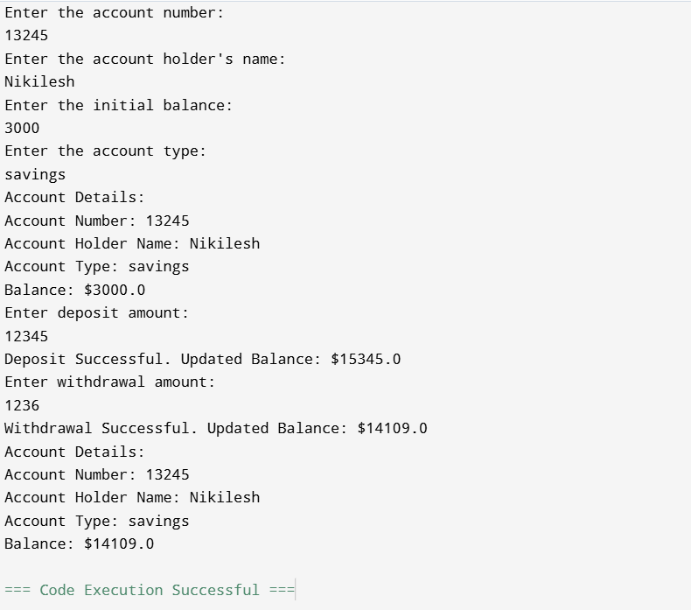

Result
The Bank Account System successfully performs deposit, withdrawal, and balance enquiry operations. It demonstrates abstraction, encapsulation, and polymorphism while simulating real-world banking logic.

Conclusion
This project creatively shows how abstraction in Java can be applied to banking systems. By defining an abstract class and implementing multiple account types, the program becomes flexible and realistic. The menu-driven interface makes it interactive and user-friendly.

